**Name: Session:**

**Programming II**

**Lab Exercise 3/6/2020 Stardate: 73177.60**

**Space Invaders**

In this lab exercise, you will build a classic video game; Space Invaders. Start by creating a Form that looks like this:

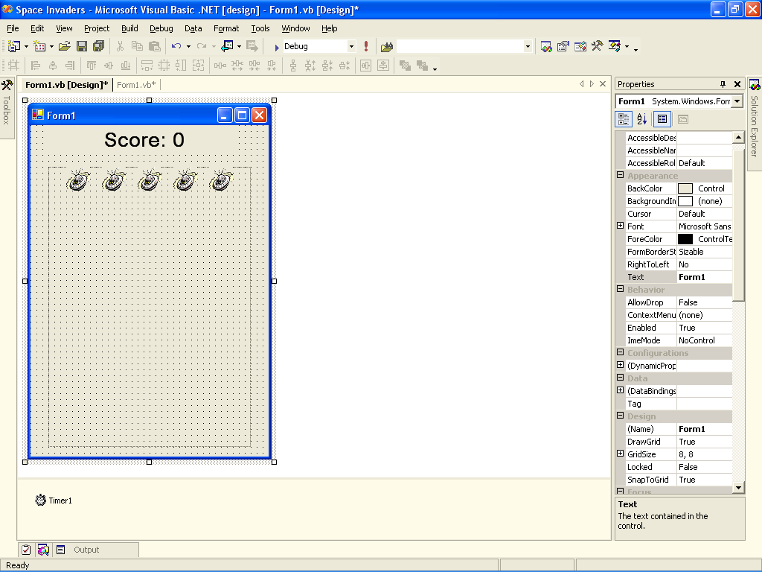

1. After your interface is created, add the following global variables to your code:

int value;

string score;

int lives;

1. Set the following timer1 properties:

Enabled = True

Interval = 300

1. Add the following to the Form1_Load event:

value = 0;

score = "Score: " + value.ToString();

lives = 10;

1. Add the following code to the timer1_Tick event:

PictureBox1.Top += 20;

PictureBox2.Top += 20;

PictureBox3.Top += 20;

PictureBox4.Top += 20;

PictureBox5.Top += 20;

checkLanded();

updateScore();

if (lives < 0)

{

timer1.Enabled = false;

lblOver.Text = "Game\n" + "Over";

}

1. Write the checkLanded( ) and updateScore( ) functions.

public void checkLanded()

{

if (PictureBox1.Top >= 344)

{

value -= 5;

PictureBox1.Top = 0;

score = "Score: " + value.ToString();

lives--;

}

if (PictureBox2.Top >= 344)

{

value -= 5;

PictureBox2.Top = 0;

score = "Score: " + value.ToString()

lives--;

}

if (PictureBox3.Top >= 344)

{

value -= 5;

PictureBox3.Top = 0;

score = "Score: " + value.ToString();

lives--;

}

if (PictureBox4.Top >= 344)

{

value -= 5;

PictureBox4.Top = 0;

score = "Score: " + value.ToString();

lives--;

}

if (PictureBox5.Top >= 344)

{

value -= 5;

PictureBox5.Top = 0;

score = "Score: " + value.ToString();

lives--;

}

}

public void updateScore()

{

lblScore.Text = score;

}

1. Now write the PictureBox click event handlers as such

private void PictureBox1_Click(object sender, EventArgs e)

{

PictureBox1.Top = 0;

value += 1;

score = "Score: " + value.ToString();

}

This example is for PictureBox1. You will have to add similar code to PictureBox1_Click, PictureBox2_Click, PictureBox3_Click, PictureBox4_Click, and PictureBox5_Click.

1. Once you have your game working, add Start, Stop, and Reset buttons.
2. Add a ProgressBar (value 0 to 100) control to keep track of your health and caused your game to end when you get to a 0 value on the progress bar. Each landing should cost the player 10 points on their progress bar.

**When you have completed your game, print a screen shot of your running game and attach to this sheet and turn in.**